Tymawr convent
Lydart
Nr Monmouth
Gwent
NP25 4RN

lizzie.allwill@gmail.com

Christmas 2013
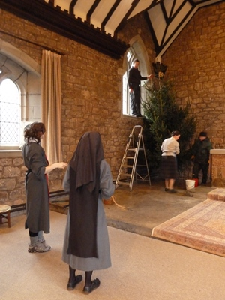
Dear Friends,

This was taken on Christmas Eve last year – we don't start Christmas until it is Christmas. Alison now has short hair, Janet is now wearing a habit. But otherwise the scene is much the same every year. Gradually there are more of us again. We have two totally different and very gifted Novices. Alison is pictured making stained glass. Both have several remarkable gifts and we are shortly to be joined by Victoria, who is totally different again and equally gifted. I am glad I am not a Novice any more!

We also still have Barnabas, gifted chef, and two cats who give much pleasure and some annoyance.

An Associate who comes to help clean the Guest House, said she had never thought of 'chief loo cleaner' as a career option, but actually it is the best job she has ever had! Because it is here. Archbishop Justin was listing the priorities close to his heart. Third, evangelism, second, reconciliation, first, Spirituality and the Religious Life. That's good. His predecessor came to my Profession, but that was fluke.

We still have our cats, and I was photographed walking them. The little grey one sharpening her claws, behaves very much like a toddler, and she is as happy as can be so long as she is the centre of attention. Recently she was contentedly sitting with me until someone came to talk to me. Then she bounced around, yowled and finally went up a tree and SHOOK it!! The ginger one is asleep in my chair as I write this. Then I was given this card ….I was amazed, so was the person who took the photo!

So, photo sheet.
Top: Pete and his brother and mother swimming in Australia. Pete and Catrin, the convent in Winter.
Next down, Catrin and Cath Duce in Australia, Cath had just had an amazing couple of months with 4 communities on the Solomon's, one of which was Sisters of the Church, and their Sr Annaliese was here when Cath sent her journal letters. Underneath is Alison in the workshop where she makes stained glass. Then me looking liking a benign old nun, and on the right, Mair, working at a German cafe on St Mary's, Scilly where she lives. I went over for a short holiday in May this year, lovely.
Next row, Lister Tonge, the new warden, with Sr Veronica Ann and Sr Gillian, our superior. She is a tall woman actually but he is miles high! Then Mair going into the sea, and on the right, Janet on her clothing day, absolutely glowing. Which is encouraging at it would indicate it was the right thing to do!
Bottom row, this group photo is typical, in that Lois set out to take a photo of the community, ie the Sisters, and ended with this except Marion (4th from left) who was photoshopped onto it from another group photo, she was in Canada when this one was taken. Typical of Tymawr because actually we are never just the Sisters; helpers, Associates, Companions, cook, always there are our friends around. On the right of the page is an old photo of Sr Veronica Ann on the tractor, and Victoria's head is inserted because she wasn't here when the group photo was taken.

The Marion who was inserted into the photo went up to see her spiritual director, a Mirfield Father, and broke her hip, she is back with us now, and will be staying rather longer than originally planned. So I am pleased to be nursing her, though very busy as it is on top of the Religious Life. Her life is complicated by the fact she is Canadian and a lot of arrangements have to be made; I do the secretarial bit too. I manage her day but the whole community is involved; including Victoria. A Wantage Sister taught me how to clean a shower in full habit and stay dry, so showering Marion while wearing full habit is no problem at all!

Next year is our centenary year and Sr Veronica Ann started preparing 14 months ahead, at least. The main event is in early May here although the actual anniversary date is in December and I believe we will be going to
Chichester, where we were founded.

CSMV A story of resurrection. Between my entering CSMV and 3rd January this year over thirty left the community, which included the whole Novitiate. Eleven of them joined the Ordinariate on 2nd January this year, leaving Wantage the next day. Immediately the 'remnant' went to work, opened the whole place up, a let in the light again, the convent is full of joyousness, graciousness and love. And common sense – they have sought help, and redid the website, starting immediately. Sr Veronica Ann and I visited on 7th January, were welcomed, talked to, given lunch and it was wonderful. All Communities form one family, and others have visited saying the same: love, transparency, hospitality. AND one of those who left is on her way back and is on the lovely website (well I like the style), in a photo on the home page. The enquirer who was there in my day, was Victoria, who is now here.

Sr Veronica Ann had four 90th birthday parties. With Victoria's arrival we are trying to reduce her working hours a little bit and give her a free day most weeks, but she is still up soon after 5.0 am and working until 8.0 pm, with a post prandial snooze.

Victoria has become an expert at washing-up and is very happy to be here, and by the time you get this should be a Postulant. Her first inter-novitiate day, meeting others who have made the same decision, was a joy. I used to love those gatherings, to be with others on the same journey, and to see how other communities do it, regardless I am afraid of the carefully prepared input!
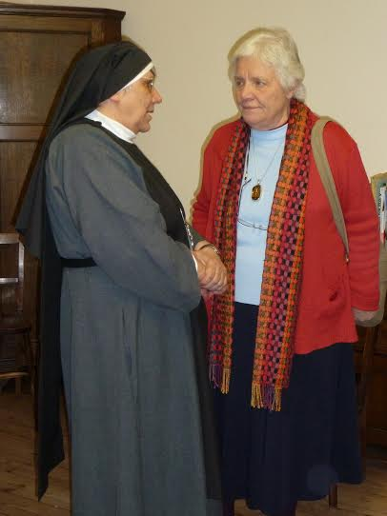
I am not alone in being devastated by Wendy Robinson's death yesterday. Most of you didn't know her, but everyone in the Anglican communities did and she supported so many of us. I have found a little photo from my Profession because I wanted to put it in. It's a year since Pat Cox died, a hard time of year for families, prayers for Katharine.

My brother had a difficult year and is now on form and I hope they and you will have a wonderful Christmas, and send you best wishes for 2014.

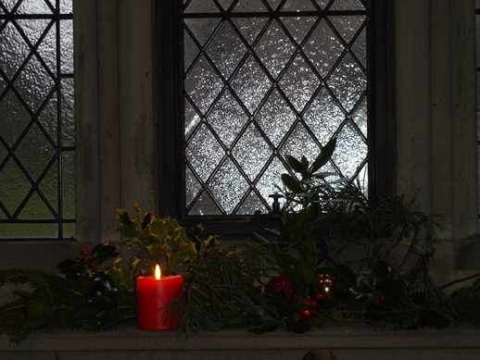
Much love from Elizabeth/Lizzie

